**Cyber sport – eSport**

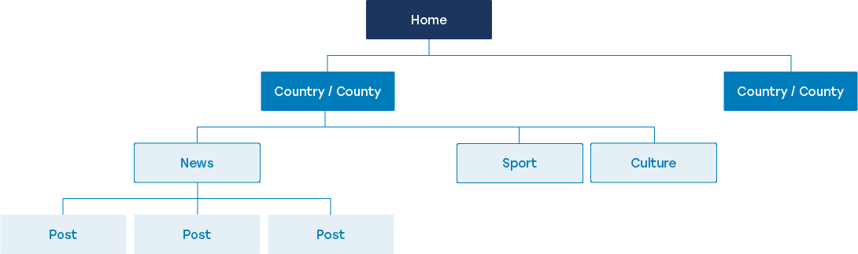

1. About application In our modern world, there are a lot of different computer games. Accordingly, there are different tournaments and competitions for each game. This site will contain different tournaments and tournament participants, to facilitate the work of the organizers of different tournaments.
2. Functionality(shortly) If we talk about the functionality of this site, it will store all the necessary data about players, about the tournament, and record how many teams were registered in a particular tournament. Each player after registering for the tournament will have access to some features that are not available to regular guests. Each player, coach, organizer will have their own personal account on our website.
3. Pages First-the main page of this site will include news from the cyber world. At the top there will be a set for selecting the necessary pages for the user. On the right side of the upper corner there is a field for logging in or registering. The set will have a page called tournaments. to avoid chaos in the pages, we will place all the tournaments for all types of cyber sports in a sorted form. Where each user can get acquainted with information about tournaments. The second page in the navbar will be called commands. In this section, the user can get acquainted with the teams and members of this team. Information about individual players will also be available.

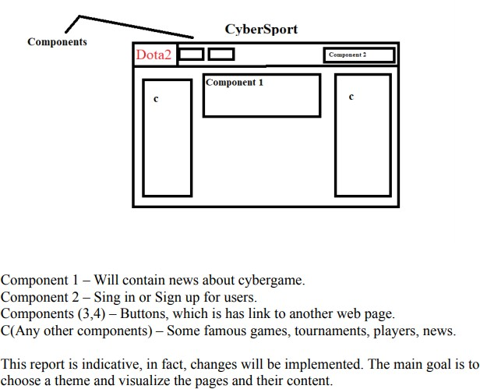

Each page has many components. Components serve to make the site work more efficiently and these components work together to create a complete user interface.

After the user logs in or registers, the page for participating in tournaments and creating a team will be available to them.

**Prototype of my eSports project:**

Here, we can see pages with their content and responsibility:

